This year, our organization has taken the Children’s Healthcare of Atlanta Strong4Life wellness pledge. We are committed to helping kids and families adopt the four Strong4Life Healthy Habits:

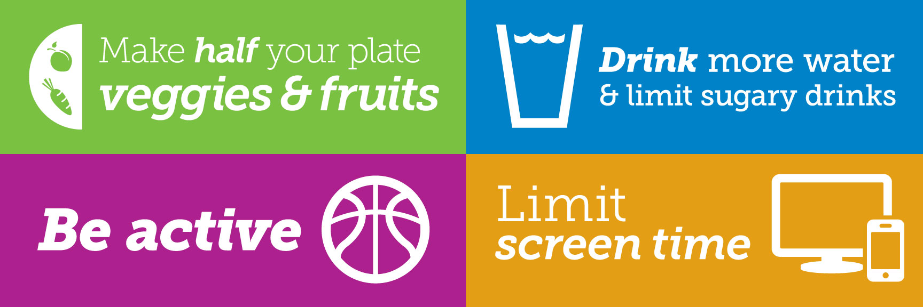

We will support healthy habits by:
- Offering healthy food and beverage choices at events, concession stands and in vending machines.
- Providing opportunities to be active.
- Ensuring youth programs provide a healthy environment and positive role models.
- Planning a variety of fun and educational wellness activities for kids and families.
- [Add any specific changes you want to share]

We need your help! Please help us promote wellness by:
- Packing your child a healthy lunch/snack.
- Providing healthy team snacks, birthday snacks, party snacks that include fruits or vegetables.
- Sending your child with water instead of juice or sugary drinks.
- Participating in wellness activities with your family.
- Ask your child to teach you an active game they learned, or practice their sport at home
with them.
- [Add any specific requests you have for parents]

We are really excited to take this wellness commitment. Please let us know if you have any questions or suggestions.

Thanks for your support,

[Name]
[Organization]

